-- Find the top 5 departments with the highest average monthly income:

SELECT TOP 5 [Department], AVG([Monthly_Income]) as avg_montly FROM [HR].[dbo].[HR_Data]

GROUP BY [dbo].[HR_Data].[Department]

ORDER BY avg_montly DESC;

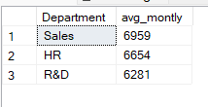

-- Calculate the percentage of employees who have left the organization for each job level

SELECT

[Job_Level],

-- Count the total number of employees for each job level

COUNT(*) AS Total_Employees,

-- Count the number of employees who have left (Attrition = 1)

COUNT(CASE WHEN [Attrition] = 1 THEN 1 ELSE NULL END) AS Ex_Employees,

-- Calculate the percentage of employees who have left

ROUND(

(COUNT(CASE WHEN [Attrition] = 1 THEN 1 ELSE NULL END) * 100.0) / COUNT(*),

2

) AS Percentage_Ex_Employees

FROM

[dbo].[HR_Data]

GROUP BY

[Job_Level];

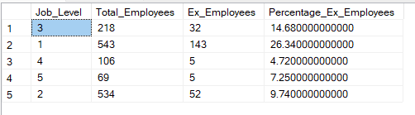

-- Retrieve employees who have the highest performance rating within each department

SELECT [Employee_Number],

[Department],

[Performance_Rating]

FROM [dbo].[HR_Data]

WHERE [Performance_Rating] = (

SELECT MAX([Performance_Rating])

FROM [dbo].[HR_Data] AS sub

WHERE sub.[Department] = [dbo].[HR_Data].[Department]

)

ORDER BY [Department], [Performance_Rating] DESC;

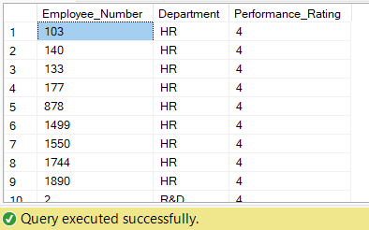

-- Find the average distance from home for employees with different levels of job involvement

SELECT [Job_Involvement], AVG([Distance_From_Home]) as Avg_Distance_From_Home

FROM [dbo].[HR_Data]

GROUP BY [Job_Involvement];

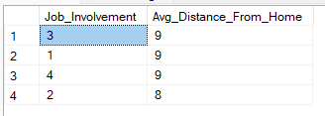

-- Calculate the average hourly rate for employees who work overtime and those who don't

SELECT

AVG(CASE WHEN [Over_Time] = 1 THEN [Hourly_Rate] ELSE null END) as AVG_Hourly_Rate_For_Overtime,

AVG(CASE WHEN [Over_Time] = 0 THEN [Hourly_Rate] ELSE null END) as AVG_Hourly_Rate_For_NON_Overtime

FROM [dbo].[HR_Data];



-- Retrieve employees who have worked for the maximum number of companies

SELECT [Employee_Number],

[Department], [Num_Companies_Worked]

FROM [dbo].[HR_Data]

WHERE [Num_Companies_Worked] = (

SELECT MAX([Num_Companies_Worked]) FROM [dbo].[HR_Data]

)

ORDER BY [Num_Companies_Worked];

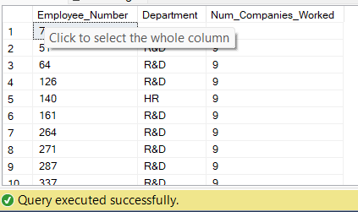

-- Find the most common education field among employees

SELECT TOP 1 COUNT(*) as Frequency, [Education_Field]

FROM [dbo].[HR_Data]

GROUP BY [Education_Field]

ORDER BY Frequency Desc;

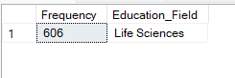

-- Calculate the average performance rating for employees in each business travel category

SELECT [Business_Travel], AVG([Performance_Rating]) AS Avg_Performance_Rating

FROM [dbo].[HR_Data]

GROUP BY [Business_Travel]

ORDER BY Avg_Performance_Rating DESC;

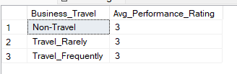

-- Retrieve employees who have the highest stock option level within each department

SELECT [Employee_Number], [Department], [Stock_Option_Level]

FROM [dbo].[HR_Data]

WHERE [Stock_Option_Level] = (

SELECT MAX([Stock_Option_Level])

FROM [dbo].[HR_Data] AS sub

WHERE sub.[Department] = [dbo].[HR_Data].[Department]

)

ORDER BY [Department], [Stock_Option_Level] DESC;

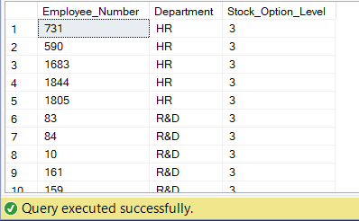

-- Find the total working years and average monthly income for employees with different levels of environment satisfaction

SELECT [Environment_Satisfaction],

SUM([Total_Working_Years]) AS Total_Working_Years,

AVG([Monthly_Income]) AS AVG_Monthly_Income

FROM [dbo].[HR_Data]

GROUP BY [Environment_Satisfaction]

ORDER BY AVG_Monthly_Income DESC;

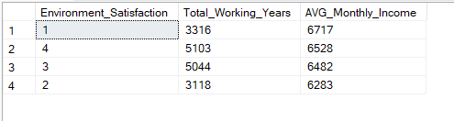

-- The number of active employees

SELECT COUNT(*) AS No_Of_Active_Employees

FROM [dbo].[HR_Data]

WHERE [CF_current_Employee] = 1;

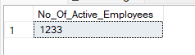

-- Find the number of employees by age group

SELECT [CF_age_band], COUNT(*) AS No_Employees

FROM [dbo].[HR_Data]

GROUP BY [CF_age_band]

ORDER BY No_Employees DESC;

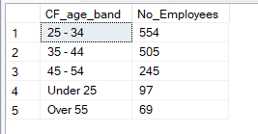

-- Display the attrition by education field

SELECT [Education_Field], COUNT(CASE WHEN [Attrition] = 1 THEN 1 END) AS No_Of_Attrition

FROM [dbo].[HR_Data]

GROUP BY [Education_Field]

ORDER BY [Education_Field];

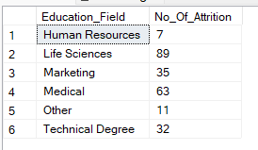

-- Attrition rate by gender for different age group

SELECT [CF_age_band], [Gender],

COUNT(*) AS Total_Employees,

COUNT(CASE WHEN [Attrition] = 1 THEN 1 END) AS No_Of_Attrition,

ROUND(100.0 * COUNT(CASE WHEN [Attrition] = 1 THEN 1 END) / COUNT(*), 2) AS Attrition_Rate

FROM [dbo].[HR_Data]

GROUP BY [CF_age_band], [Gender]

ORDER BY [CF_age_band], [Gender];

